**Name :** Dhavalkumar Vijaykumar Patel

**Subject :** Essential of Cyber Security and Cyber Waefare

**Class :** M.Sc Cyber Security

**Semester :** 1

**Lab 6 :**

1. Nmap – multi-functional scanning and enumeration utility used to quickly gather info about network hosts (incl. their availability, ports, IP addresses, names, their OSs, services they run).  
   Used by hackers as the first attack step

**$ sudo nmap -A -Pn -O 10.0.2.8**

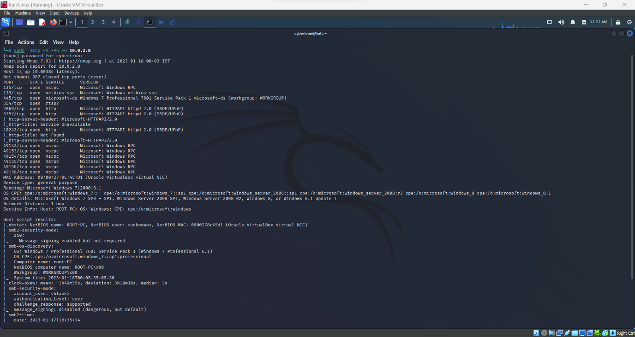

1. Banner Grabbing

**$ nmap -sV --script=banner 10.0.2.8**

